第六章 雞尾酒的調製
一
調酒用器具

※ 請將下列表格中的器具與名稱做配對，並寫出器具的中文：
A. |  | B. |  | C. |  | D.
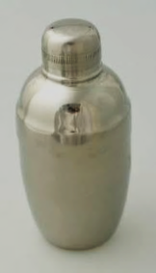 |  | 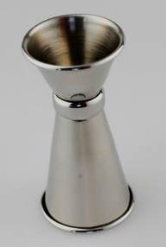 |  | 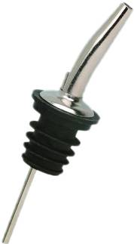 |  | 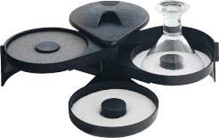
E. |  | F. |  | G. |  | H.
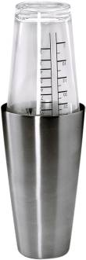 |  | 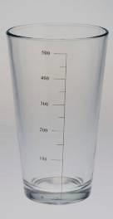 |  | 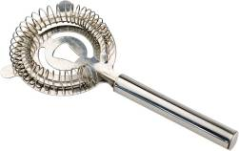 |  | 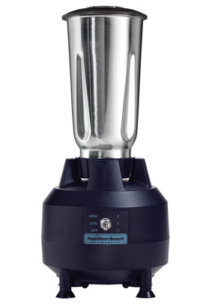
I. |  | J. |  | K.
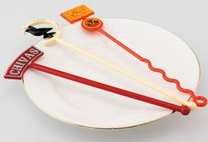 |  | 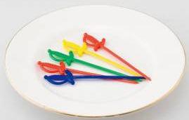 |  | 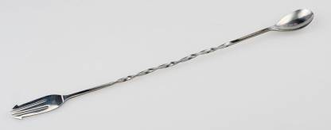
1.( ) | Cocktail Pick [＿＿＿＿＿] |  | 7.( ) |  | Shaker [＿＿＿＿＿]
2.( ) | Blender [＿＿＿＿＿] |  | 8.( ) |  | Stir Stick/ Stirrer [＿＿＿＿＿]
3.( ) | Boston Shaker [＿＿＿＿＿＿] |  | 9.( ) |  | Glass Rimmer [＿＿＿＿＿]
4.( ) | Pourer [＿＿＿＿＿] |  | 10.( ) |  | Jigger [＿＿＿＿＿]
5.( ) | Strainer [＿＿＿＿＿] |  | 11.( ) |  | Bar Spoon [＿＿＿＿＿]
6.( ) | Mixing Glass [＿＿＿＿＿]
二
常用的杯子
沒杯頸(腳)的杯子:＿＿＿＿＿
B
A
有杯頸(腳)的杯子:＿＿＿＿＿

※ 請畫出下方列出的杯子形狀，並請說明他是有腳杯還是平底杯：
Shot Glass
Cocktail Glass
Liqueur Glass
Sour Glass
Collins Glass
Toddy Glass
Hurricane Glass

三
裝飾物
不可以吃的裝飾物:＿＿＿＿＿
可以吃的裝飾物:＿＿＿＿＿

※ 下列表格是裝飾物的英文名稱，請將裝飾物的中文意思填上：
1. Olive: | 5. Orange Wedge:
2. Salt Rimmed: | 6. Nutmeg Powder:
3. Cocktail(Pearl) Onion: | 7. Lemon Spiral:
4. Celery Stick: | 8. Pineapple Slice:

四
調酒的方法
Stir(＿＿＿＿＿＿)
Float(＿＿＿＿＿＿)
Pour(＿＿＿＿＿＿)
EX:＿＿＿＿＿、＿＿＿＿＿＿
EX:＿＿＿＿＿、＿＿＿＿＿＿
Shake(＿＿＿＿＿＿)
Blend(＿＿＿＿＿＿)
EX:＿＿＿＿＿、＿＿＿＿＿＿
EX:＿＿＿＿＿、＿＿＿＿＿＿
EX:＿＿＿＿＿、＿＿＿＿＿＿
Build(＿＿＿＿＿＿)
Layer(＿＿＿＿＿＿)
EX:＿＿＿＿＿、＿＿＿＿＿＿
EX:＿＿＿＿＿、＿＿＿＿＿＿

五
雞尾酒種類

Sour(＿＿＿＿)

 | 成份 | 調製法 | 裝飾物 | 杯器皿
杏仁酸酒  (____________) | 45ml  30ml  15ml | (________) | Orange Slice  &  Lemon Peel | Sour Glass  (____________)
Collins(＿＿＿)

Sling(＿＿＿＿)

 | 成份 | 調製法 | 裝飾物 | 杯器皿
新加坡司令 (______________________) | 40ml _____  20ml _____________  5ml Triple Sec  5ml Benedictine  10ml Grenadine  80ml P/J  30ml __________  Dash Bitters | (________) | PineappleSlice  &  Cherry | (____________)
Buck(＿＿＿)

Punch(＿＿＿)
酒
糖
香料

 | 成份 | 調製法 | 裝飾物 | 杯器皿
拓荒者賓治  (____________) | 60ml Dark Rum  30ml Lemon Juice  15ml Granadine  Top with Soda Water | (________) | Orange Slice & Lemon Slice & Bitters | (____________)
Frozen(＿＿＿)

Fizz(＿＿＿)

 | 成份 | 調製法 | 裝飾物 | 杯器皿
琴費士  (____________) | 45ml  30ml  10ml  Top with | (________) |  | (____________)

